Change Orders/Red Line Revisions in Praxis
When you receive changes after the building has been paid for, you will need to calculate the cost of the revision, get it okayed by the customer, and add the change to Red Line Changes in the Sales Release/Building Order form in Praxis.
To do this:
- Redlines arrive from dealer
- Sales person goes to the building serial number in Praxis to the redlines tab.
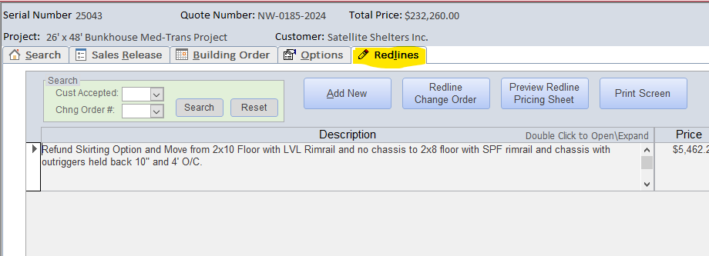
- Build out the changes in Praxis. Make sure to note all changes in the description. The description is all the customers will see for explanation of the change order.
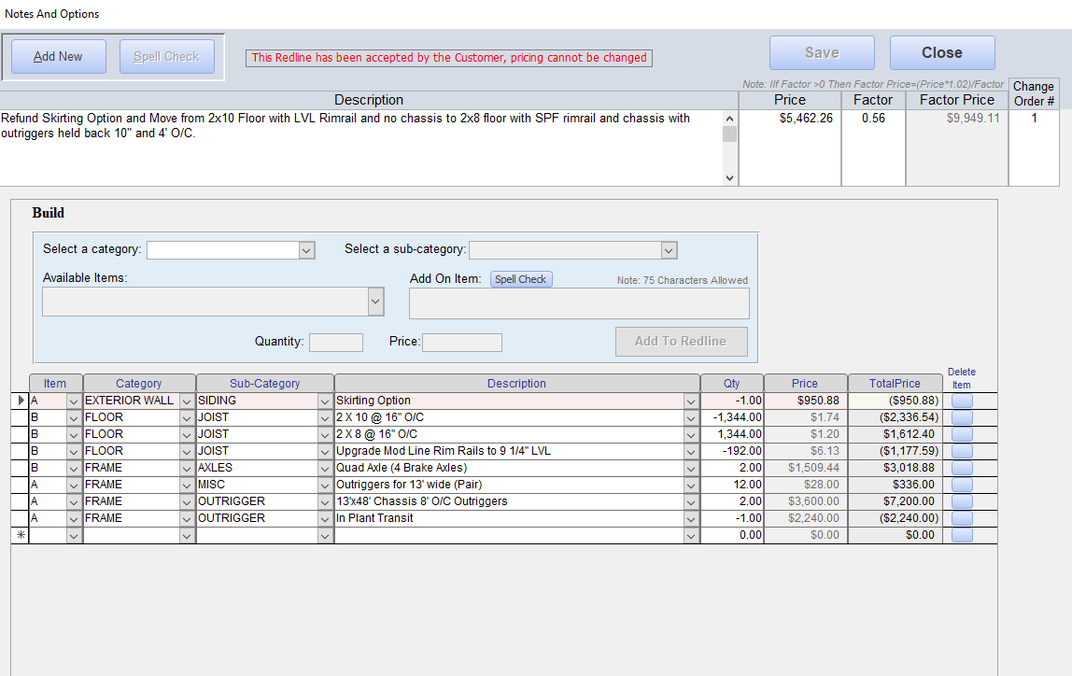
- Add a factor to the change order.
  - If handoff to design is yet to occur, do the same factor as the building.
  - If the building has been drawn and ran through the states, then subtract 2 factor points (i.e. 0.56 0.54).
  - If the building is on the line when changes are requested, subtract 4 factor points (i.e. 0.56 0.52).
- Click the “Redline Change Order” button to print the change order to PDF. Save the PDF to the Purchase Order and Change Orders folder in the Sales subfolder of the Building file. Redlines do not get accepted and released to engineering until any/all costs are approved.
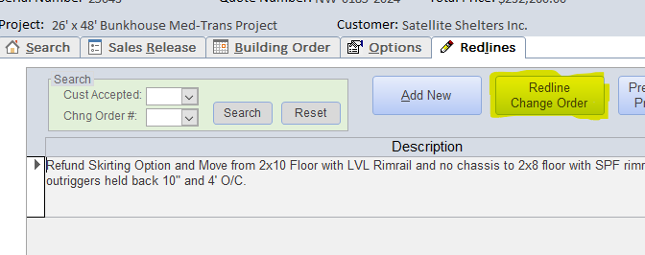
- Email the change order to the customer. Ask for them to sign the change order and send an updated PO. Make sure to explain the contents of the change order to them.

ONCE CUSTOMER SIGNS CHANGE ORDER
- Once the customer has signed the change order, save the signed copy to the Purchase Order and Change Orders folder in the building file. Delete the old unsigned version you have saved there.
  - If the customer also sent an updated PO, verify the price is correct and save it in the same folder.
    - Create a new folder called “Old Purchase Order Versions” and send the last PO version to this subfolder.
- From the Sales drive, find the “Change Order Internal Signatures Template” PDF. Copy and paste the form from this PDF onto your change order.
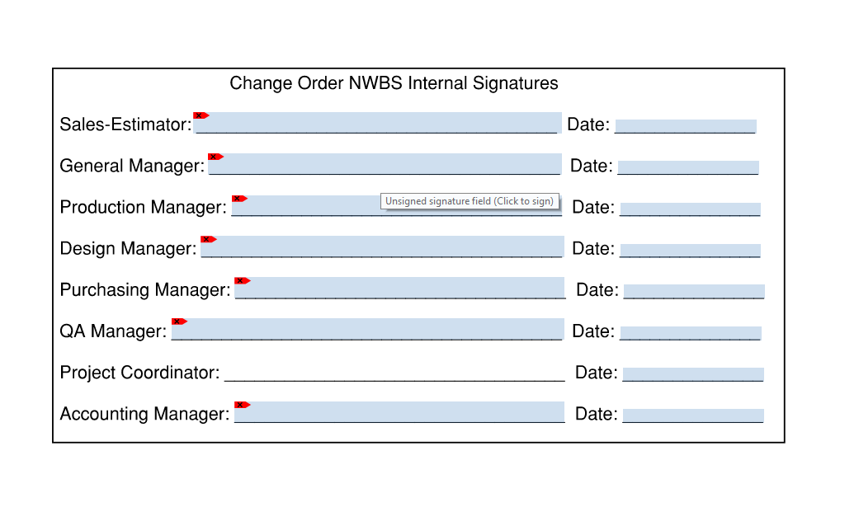
- Resave the change order with the form you pasted onto it.
- Email the General, Production, Design, Purchasing, QA, and Accounting Manager and the Project Coordinator asking them to sign the document.
  - Send them an exact file path to get there by right clicking the change and creating a shortcut.
    - Then, right click the short cut and click on properties in the menu.
    - In Shortcut properties, copy the target location.
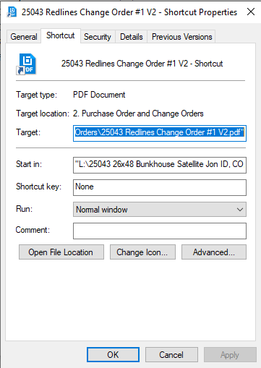
    - Paste the target location into your email.
    - Delete the shortcut you created. Be careful not to delete the file.

ONCE All INTERNAL PARTIES HAVE SIGNED
- Go back into Praxis and note that the customer accepted the change order.
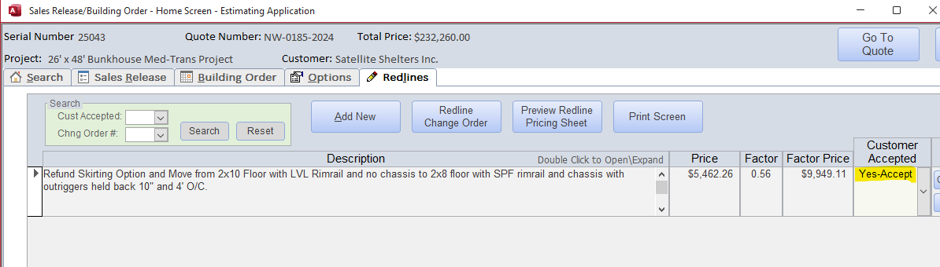
- Add the parts of the change order accepted into the sales release.
- Reprint the sales release and building order sheets. Create a new folder in the building file titled “Old Sales/Order Sheets” and move the old sales release and building order sheet files into that folder.
- Send the signed copy of the change order, the new sales release, the new building order sheet, and the updated PO (if received) to all managers and the project coordinator. Make the email out to the Accounting Manager and let he/she know that the change order has been approved and what the new building cost is.

